06 November 2013

Dear Colleagues,

Thank you for supporting our research by collecting tissues from domestic – random bred – feral cats from your world region. Our previous studies have focused on the population dynamics and migrations of cat populations from around the world, including the genetic distinction of breeds and regional populations. From our investigations (attached are 2 previous studies), we have discovered approximately ten (10) genetically unique cat populations in the world, including: Western Europe, the Iberian Pennisula, the Mediterranean Region, Egypt, Iran/Iraq, the Arabian Sea region, East Asia, Southeast Asia, the Nordic Region, and India. Our current ongoing evaluation of an extended analysis of world regions is in preparation.
The accuracy of these studies is strongly affected by the areas in which the cats are sampled, therefore, we have initiated a new effort to collect cats from new areas of the world, overlapping previous works and attempting to fill gaps in our regional collections. Island populations are of particularly interest. We have generally collected samples from cats by buccal swabbing with cytological brushes and or cotton swabs. Due to new opportunities with whole genome sequencing, a more stable and a more abundant source of DNA is required. Therefore, we have asked that you collect the discarded tissues from neutering and spaying of cats, the gonads (ovaries and testicles), as the DNA source for this new study. We hope to whole genome sequence at least 2 cats from every collection site and then perform high-density DNA marker screening on the remaining samples.
A strong sampling for any region is generally ~30 individuals. We are asking you to attempt to balance males with females, ~15 of each gender, but sampling does not have to be exact. The cats should not be related (to your best estimation), although we recognize that feral cats from a region or population will have some level of kinship. The gonads should be put into 70% alcohol immediately after removal during surgery. The DNA will stay stable in the alcohol and they can be kept at room temperature or in the refrigerator for months to years. At a later date, we will arrange shipment or collection of the samples so that they can be processed in our laboratory here at the University of Missouri – Columbia.
The goal is to have most collections completed by the end of January in order to meet future deadlines for access to funding sources and timing on instrumentation for whole genome sequencing. The sequencing process itself, including sample preparations, can take up to 2 months, not including data analysis!
Attached are additional instructions, however, the overall collection is fairly routine. We offer compensation or a donation to any collection group, then providing acknowledgements in our publications. For those associated with universities and who may not need compensation, we can offer a co-authorship on the first publication that uses the samples you have provided. As co-author, you will then be expected to contribute comments to the publication. All collaborators will have an opportunity to review the manuscript prior to publication.
We hope that this interaction is the beginning of long standing collaborations. Our laboratory often hosts foreign students and we welcome opportunities for any student and visiting scientist with interests in genetics and veterinary medicine. We greatly appreciate your assistance and hope we get to meet as part of this research project.

Best regards,

Leslie A. Lyons, PhD

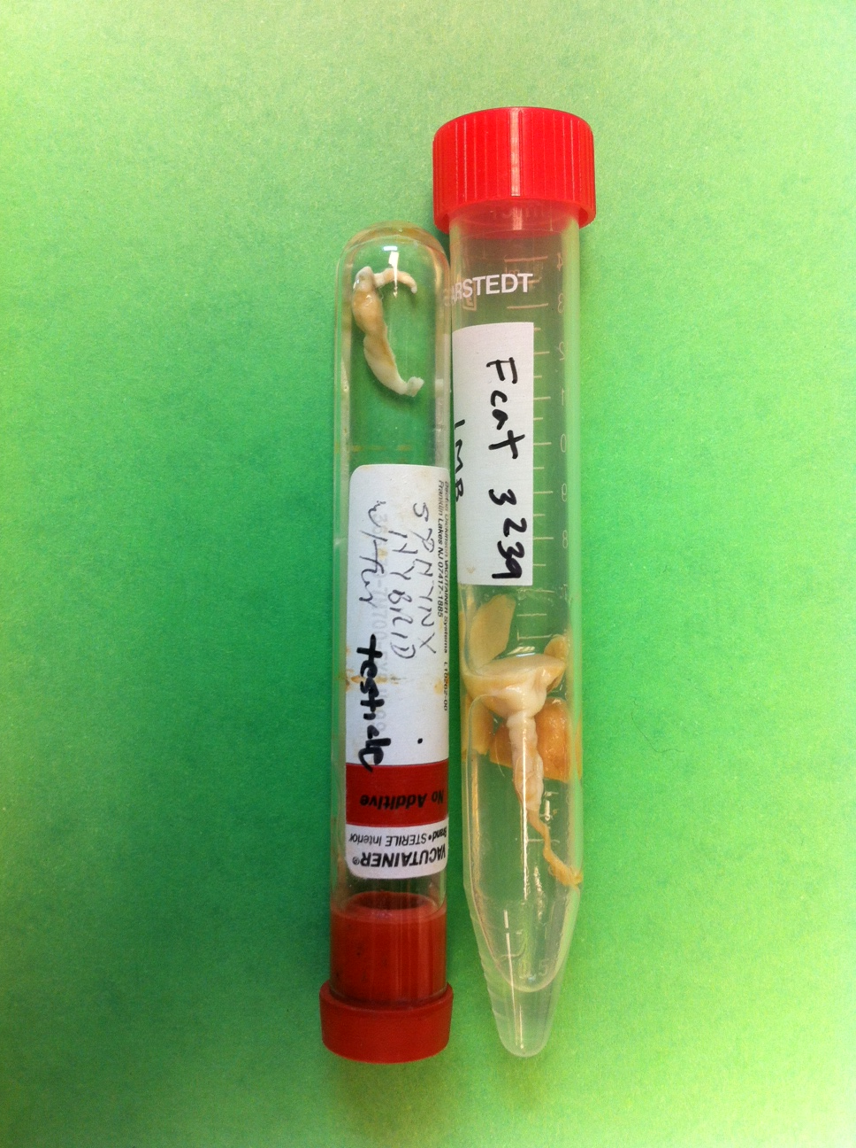
Example of cat gonads in 70% alcohol
Cat DNA Collection Collaborators

Country | Collaborator | E-mail | City
Greece | Emmanouel Mastromanolis | emastromanolis@hotmail.com | Athens
Greece |  |  | Lesvos Islands
Indonesia | Christia Dilla | info@pondokpengayomsatwa.com | Pondok Pengayom Satwa
India | H.K. Chaudhary | ctlhkc@rediffmail.com
 | biswapati mandal | mandalbiswapati@rediffmail.com | West Bengal, India
Oman | Elke Heitz | info@muscatvets.com | Muscat | Al Qurum Vet Clinc | www.muscatvets.com
Galapagos | Tod Emko | todemko@gmail.com |  | Darwin Animal Doctors
Iceland | Hrund Ýr Óladóttir | dyra@simnet.is | Reykjavík | Dýraspítalinn í Víðidal  Vatnsveituvegur 4  110 Reykjavík  +354 5409900
Iceland | Elfa Ágústsdóttir | elfa@nett.is | Akureyri
Bangladesh | Mahbub Alam | asamahbub2003@yahoo.com | Mymensingh | Dept. of Veterinary Medicine  Faculty of Veterinary Science  Bangladesh agricultural University  Mymensingh-2202, Bangladesh
Nepal | Pan Singh Thagunna | pstvet@yahoo.com | Kathmandu | www.katcentre.org.np | Animal Hospital & Research Center, Kathmandu, 016925020
Dominican Republic | Emma Clifford  Katherine Polak | clifford@animalbalance.org; polakk@ufl.edu |  | Ainimal Balance; University of Florida
East Timor | Antonio | dilivetclinic@gmail.com | Dili | Dili Veterinary Clinic TOHA | TOHA (Timoroan Hadomi Animal - Timorese Animal Lovers)  670 7723 3792
Korea | HyungChul Rah | rah.remnant@gmail.com
China | PENG Guang-neng | pgn.sicau@163.com
China | Jainmin Chen | jmchen@yzu.edu.cn
Poland | Barbara Kosowska | barbara.kosowska@up.wroc.pl
Grand Caymans | Brian Roberts | broberts@smu.ky |  | St. Matthews Veterinary University
Jordan | Ala Shehadeh, | vetzone@gmail.com | Amman | VetZone Pet Health Center, | 336, King Abdullah II Str. (Madina Tibiyya str.)  Tel. +962 6 582 3244  Mob. +962 79 969 99 88  www.facebook.com/groups/vetzone  www.facebook.com/vetzone
Jordan | Nassem N. Naimi | bestfriend.jo@gmail.com | Amman | Best Friend Veterinary Clinic | www.bestfriend-jo.com  Amman - 7th circle Ibn Al-FATA st.  +962 (0)78 8588067  +962 (0)79 6274565
Romania | Gallia Butnaru | galliab@yahoo.com | BONCA GHEORGHE <ghitabonca@gmail.com>
Germany | Otmar Distl | Ottmar.Distl@tiho-hannover.de
Denmark | Suzanne Wehnert | Susanne Wehnert <susannewehnert@gmail.com>
Russia | Oleg Viktorovich Andrukanets | VetDok-R <irkvetova@bk.ru>
Russia | Pavel Borodin | borodin@bionet.nsc.ru | borodin@bionet.nsc.ru
Russia | Sergey Kholin | h.axyridis@mail.ru | h.axyridis@mail.ru
Madagascar | Julie Pomerantz D.V.M. | jpomerantz@earthlink.net | jpomerantz@earthlink.net
Kuwait | Hasan Alhaddad | hhalhaddad@gmail.com | hhalhaddad@gmail.com
Hungary | Dr. Csikós Károly Miklós | kcsikos@mancsok.hu | kcsikos@mancsok.hu
Russia | Yana Rusakova | Яна Русакова <yarojana@mail.ru> | Яна Русакова <yarojana@mail.ru>
Russia | Valentina Salovarova | vsalovarova@rambler.ru | vsalovarova@rambler.ru

